Welcome!
Date
Name
Spouse
Address
City
State Zip _________
Email

Please Contact By
❑ Card  Phone  Visit

Telephone Best Time to Call
Home ______________
Work ______________

Guest: First Time Second Time
Are you a church member: yes no
Church
City, State

Circle Appropriate Age/Grade Group(s)
Preschool: Ages: B-1 2-3 4-5
Children: Grades: K 1 2 3 4 5 6
Youth: Grades: 7 8 9 10 11 12
Adults: Ages:18-29 30s 40s 50s 60s+

How did you learn about our church?
Newspaper Friend Yellow Pages Mail
Other

I am a guest of:

New in the Community? Yes No
Names & ages of children at home

Weekly Service & Activity Schedule

May 21, 2017
9:45 a.m. Sunday School
11:00 a.m. Worship Service
12 noon Graduate Lunch
“The Burden of Want” Evening Video/Bus Mtg

Week of May 21, 2017
Tuesday 6:00 pm…………………..………………….Card Class
Wednesday 6:30 pm………………..…Meal/Bible Study
Thursday 10:00 am…………………..Adult Fellowship
Friday 6:30 pm……………..……………..Men’s 42 Night

May
25…………………………………………….Adult Fellowship
28………………….…………………..Memorial Day Service
June
4………………………………......New Commandment Kids
8……………………………………………..Adult Fellowship

Congratulations Class of 2017!!

Mariah Garza – Lexington HS
Gunner Godley – Lexington HS
Leslie Knobloch – Texas A&M School of Nursing

Preteen Camp!!!
Highland Lakes
July 30 – Aug 2
Anyone interested in attending contact Becky Yount by May 28. Must have completed 3rd thru 6th grade.
The spots for boys will be limited to the first 8 as there is only one male sponsor.

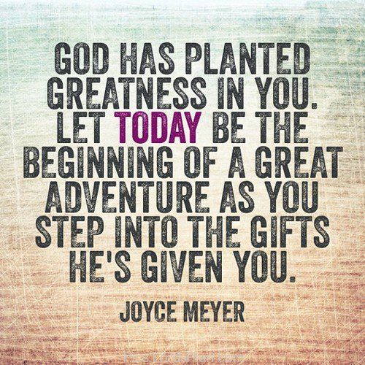

Knobbs Springs Baptist Church

May 21, 2017

Church Information:

KnobbsSpringsBC.com KnobbsSpringsBaptist@gmail.com

1662 CR 305, McDade, Texas 78650 512-273-2743

David Atwood, Pastor Cell 512-470-5098

Patti Radford, Office Manager Cell 512-968-7821

